On the Informational Asymmetry between Upper and Lower Bounds for Ultrametric Evolutionary Trees
Ting Chen and Ming-Yang Kao
The 7th Annual European Symposium on Algorithms (ESA'99), 1999, pp. 248-256
Abstract
This paper show that the tallest ultrametric tree exists and can be constructed in O(n²) time, while the existence of the shortest ultrametric tree depends on whether the lower bounds are ultrametric.
- Introduction
In practice, when distance measures are uncertain, a distance is expressed as an interval, defined by a lower bound and an upper bound for the true distance.
- Constructing the tallest ultrametric tree
Given an upper bound matrix, the tallest ultrametric tree, where the distance of any two leaves reaches the maximum among all satisfied ultrametric trees, can be constructed in O(n²) time.
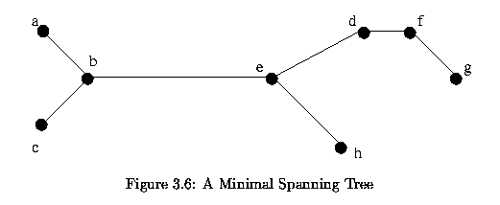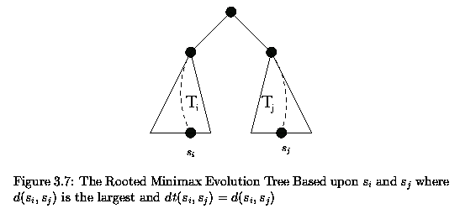
- Asymmetry between upper and lower bounds
Given a lower bound matrix, the shortest ultrametric tree, defined similarly to the tallest ultrametric tree, exists if and only if the matrix is ultrametric.
- Query of ultrametric trees
If a lower bound matrix and an upper bound matrix are given, how fast can we determine whether an ultrametric tree satisfies both constraints? This problem is useful, for example, for developing an interactive software for finding the most suitable tree among many. We can preprocess the upper bound matrix M^{h} in O(n²) time, so that for any given ultrametric tree V, whether V satisfies M^{h} can be determined in O(n) time.
- Open problem
By preprocessing, is there an algorithm that can test whether a tree satisfies a lower bound matrix faster than O(n²) time?
Created by: Chia-Mao Huang
Date: Oct. 3, 2000

